Campus Rental – UI Design Guidance

Overall Design Direction
Campus Rental should have the look and feel of a modern university self-service portal. The interface should be clean, professional, simple, and moderately modern without becoming overly decorative or resembling a commercial apartment-rental website.
The application should prioritize clarity of workflow. Students should immediately understand where they are in the housing process and what action they need to take next. Housing Officers should have an efficient administrative interface for reviewing applications and managing housing inventory.
The overall visual style should use a dark navy primary color, white and light-gray content areas, and a brighter blue accent for primary actions. Status indicators can use restrained semantic colors to distinguish successful, pending, cancelled, unavailable, and inactive states.
Typography should use a clean modern sans-serif font with generous spacing and clear visual hierarchy. Cards, buttons, and panels may use subtle rounded corners, but the interface should remain professional rather than overly stylized.
The overall goal is for Campus Rental to look like software that a university could realistically provide to students and Housing Officers, rather than a generic CRUD application.

Shared Application Layout
Students and Housing Officers should use the same basic application shell.
The layout will include a top header containing the Campus Rental identity and information about the currently signed-in user. A persistent left-side navigation menu will provide access to the application's major functions.
The navigation options will change according to the authenticated user's role.
Student Navigation
Campus Rental

Dashboard
Housing
My Application
My Housing
My Lease

Housing Officer Navigation
Campus Rental

Dashboard
Housing Inventory
Applications
Assignments
Role-based navigation should complement backend authorization. Hiding an administrative option from a Student does not replace API-level access control.

Student Dashboard
The Student Dashboard should focus on one primary question:
Where am I in the housing process, and what do I need to do next?
The application lifecycle should therefore be one of the most prominent elements on the dashboard.
A progress indicator should display major milestones such as:
Application Progress

✓ Submitted
✓ Approved
● Room Secured
○ Lease Signed
The dashboard should also display the student's current or reserved housing when applicable, including the building, room, bed, and assignment status.
A prominent Next Step section should direct the student toward the appropriate action. Examples include submitting an application, browsing available housing, securing a room, completing a lease, or viewing a confirmed housing assignment.
The dashboard should avoid unnecessary statistics that do not help the student complete the housing process.

Browse Housing
The housing browser should focus on university housing inventory rather than attempting to resemble a commercial apartment marketplace.
The initial view should display available residence buildings as cards. Each card may include:
Building image
Building name
Address or brief description
Number of available beds
View Rooms action
A simple building search may also be provided.
Selecting a building should display its rooms and individual beds. Students should be able to clearly distinguish between available and unavailable beds.
For example:
Room 201
Bed A Available [Select Bed]
Bed B Available [Select Bed]

Room 202
Bed A Reserved
Bed B Available [Select Bed]
Unavailable beds should remain visible when useful for context but should not be selectable.

Secure Room Confirmation
Securing a room is an important business operation and should require confirmation rather than occurring immediately when a student selects a bed.
The confirmation dialog should clearly identify:
Building
Room
Bed
Academic Year
It should explain that securing the bed reserves it for the student's housing application and begins the leasing process.

The student should then choose between:
Cancel
Secure Room
If another student secures the selected bed before the request completes, Campus Rental should provide a clear message explaining that the bed is no longer available and return the student to available housing.
This interaction will also provide a visible representation of the application's concurrency protection and HTTP 409 Conflict behavior.

Student Housing Application
The Student Application page should provide a simple summary of the student's application and its current status.
Information may include:
Academic Year
Application Status
Submission Date
Approval Date
Room Secured Date
Completion Date
The page should also provide the appropriate next action based on application status.
For example, an approved application may display:
Your application has been approved.

You can now browse available campus housing
and secure a room.

[ Browse Housing ]
Housing Officer notes must never appear in the Student interface. The backend Student API response should omit this information entirely rather than relying on the frontend to hide it.

Student Lease
The Lease page should clearly communicate where the student is in the lease-signing process.
A visual progression may show:
✓ Generated
✓ Sent for Signature
● Awaiting Your Signature
The primary action would be:
[ Review & Sign Lease ]
After successful electronic signature, the interface should show:
✓ Lease Signed

Your housing assignment is confirmed.

[ View My Housing ]
The interface should focus on the Campus Rental business workflow rather than exposing unnecessary DocuSign-specific implementation details.

Housing Officer Dashboard
The Housing Officer interface can use a more administrative dashboard style.
Useful summary cards may include:
Available Beds

Applications Awaiting Review

Confirmed Assignments
The dashboard should also provide a list of applications requiring attention.
For example:
Student Submitted Status Action

Sarah Miller Sep 14 SUBMITTED [Review]
John Smith Sep 15 SUBMITTED [Review]
Unlike the Student Dashboard, operational counts are useful here because they help Housing Officers understand current workload and housing availability.

Housing Officer Application Review
Housing Officers should have a dedicated application-review view.
The page should display relevant student information, application information, and internal Housing Officer notes.
Example content:
Student
-----------------------------
Sarah Miller
Student ID: 912345678
Gender: Female

Application
-----------------------------
Academic Year: 2026-2027
Submitted: September 14, 2026
Status: SUBMITTED

Housing Officer Notes
-----------------------------
[ Internal notes field ]

[ Save Notes ] [ Approve Application ]
Administrative actions should be clearly distinguished from ordinary information.
Housing Officer notes are internal information and should only be returned by authorized administrative API endpoints.

Housing Inventory Management
Housing inventory management should visually follow the domain hierarchy:
Building
↓
Room
↓
Bed
Rather than using a large spreadsheet-style editor, the interface should display an expandable or hierarchical inventory structure.

For example:
East Residence Hall [Edit Building]

Room 201 [Edit]
Bed A Active [Disable]
Bed B Active [Disable]

Room 202 [Edit]
Bed A Active · Confirmed
Bed B Active · Available

[ + Add Room ]

West Residence Hall [Edit Building]

...

[ + Add Building ]
Buildings, rooms, and beds should normally be enabled or disabled rather than deleted, matching the application's data-retention design.

Status Presentation
Statuses should be visually consistent throughout Campus Rental.
Examples include:
✓ Approved / Confirmed / Signed

● Submitted / Reserved / Pending

! Cancelled / Error / Conflict

— Inactive / Unavailable
Color may reinforce these states, but the interface should not depend solely on color. Text labels and icons should also communicate status.

Responsive Design
Campus Rental should primarily target desktop and laptop browsers because Housing Officer administration and housing selection benefit from additional screen space.
The Angular interface should still respond cleanly to smaller screens. Navigation may collapse, cards may stack vertically, and tables may adapt as necessary.
A dedicated mobile application is outside the project scope.

UI Implementation Principles
The UI should follow several consistent principles:
- Keep Student workflows task-oriented and simple.
- Make the student's current housing-process status obvious.
- Always provide a clear next action when one exists.
- Keep Housing Officer functionality operational and efficient.
- Use the same visual language across Student and Housing Officer views.
- Never rely on hidden frontend elements as a substitute for backend authorization.
- Make important operations such as Secure Room and cancellation require clear confirmation.
- Display useful errors in user-friendly language rather than exposing technical/database messages.
- Keep external implementation details such as DocuSign envelope identifiers out of normal user-facing screens.
- Favor reusable Angular components for cards, status indicators, dialogs, navigation, and common form elements.

Initial Mockup Set
Six mockups will serve as the primary visual reference during Angular development:
Mockup Usage: These mockups establish the intended visual style, layout, navigation, and interaction patterns for Campus Rental. They are design references rather than pixel-perfect specifications. Application behavior, authorization, data fields, and business rules are governed by the Capstone Project Plan and implemented domain model.
1. Student Dashboard
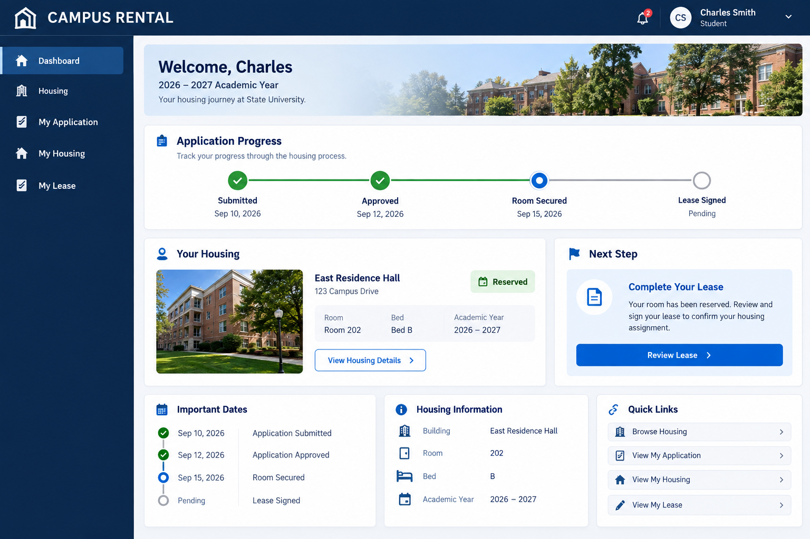

2. Browse Housing / Room & Bed Selection
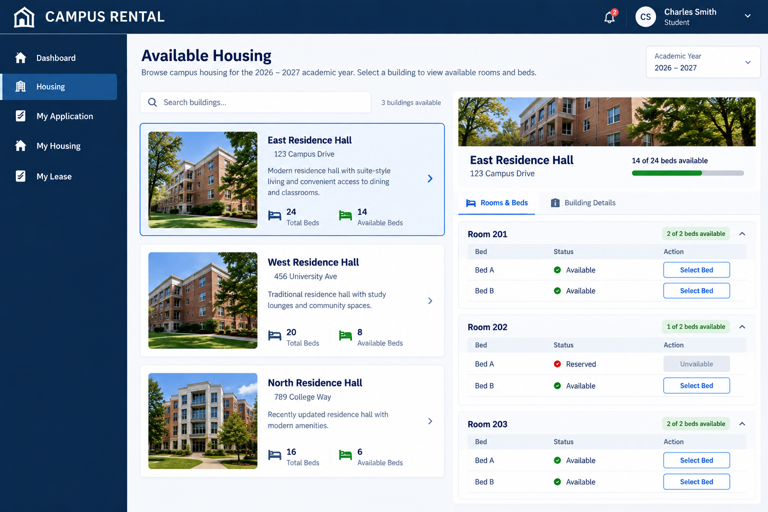

3. Secure Room Confirmation
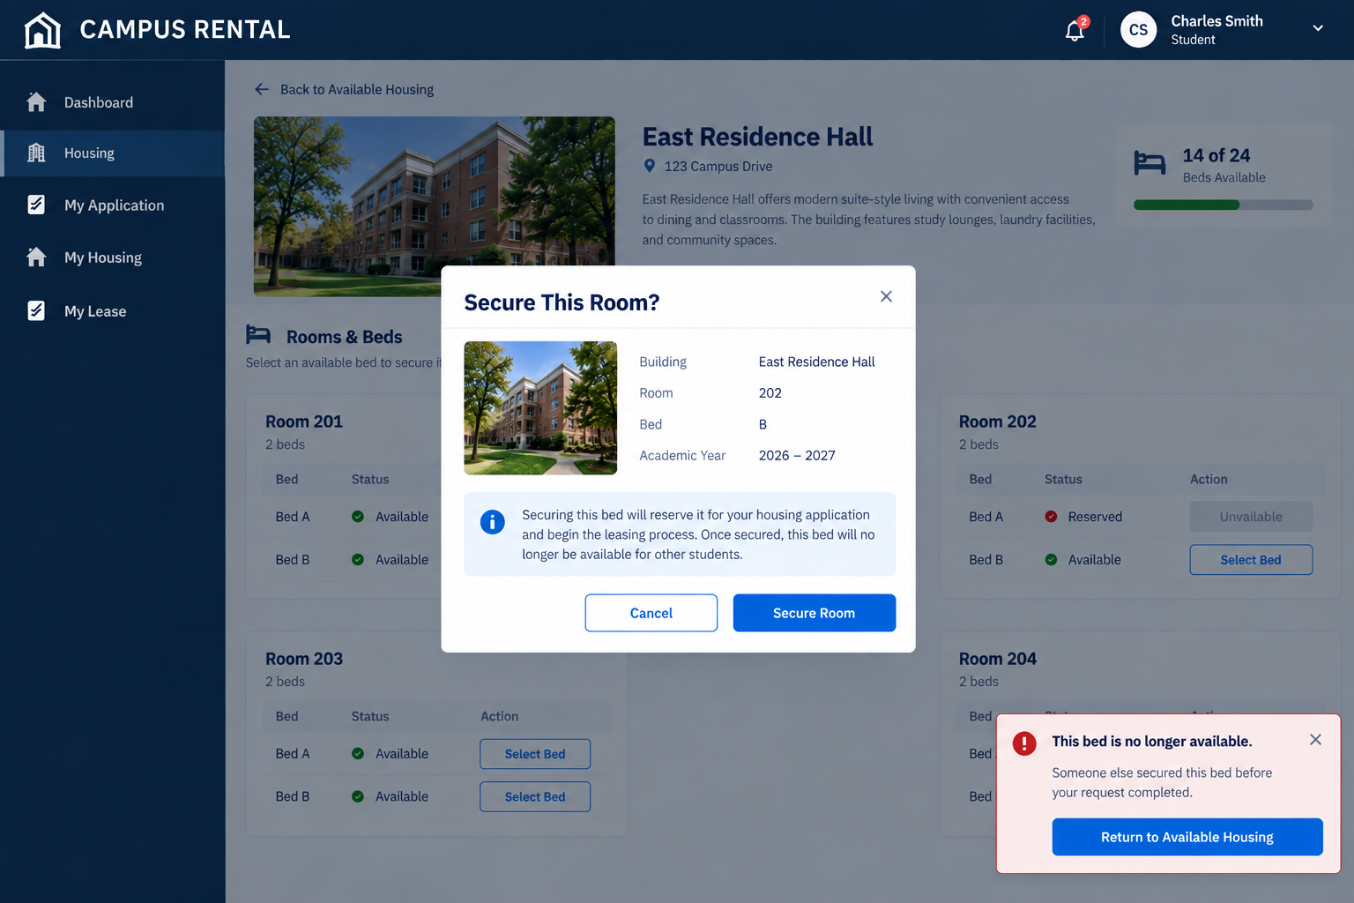

4. Student Lease
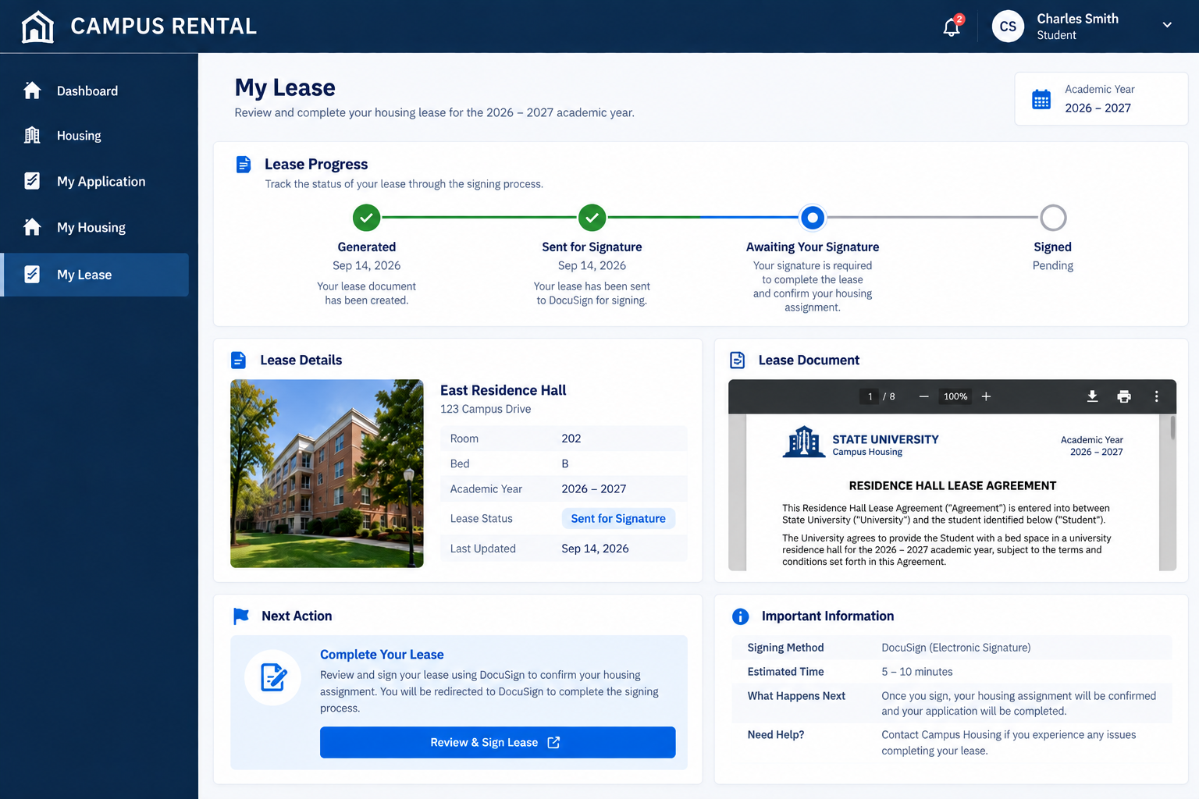

5. Housing Officer Dashboard / Application Review
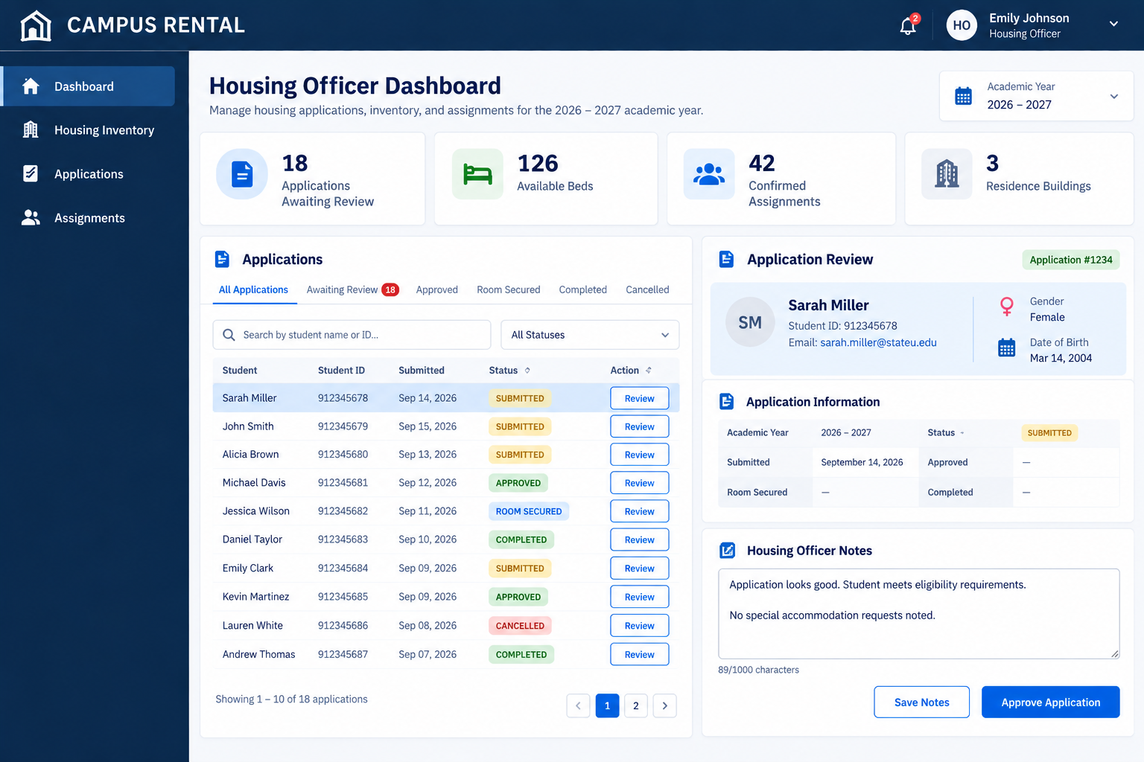

6. Housing Officer Inventory Management
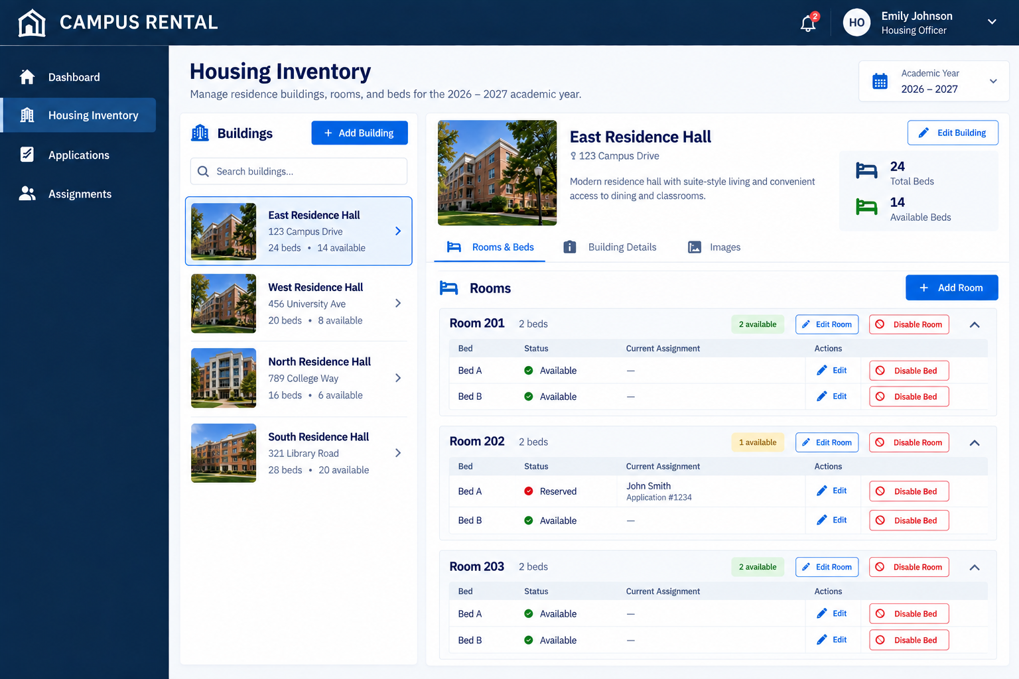

Together, these screens establish the major UI patterns needed throughout Campus Rental: navigation, cards, workflow progress, inventory selection, confirmation dialogs, administrative tables, forms, status indicators, and role-specific functionality.

